**13.Manual Assign IP address to machine.**

There are two ways we can assign a static IP address in CentOS 7 systems,

1- Using Network manager

2- Assigning IP using network files

Let's discuss both these methods one by one.

## **1- Assign static IP using Network Manager**

To configure a static ip address using the network manager, we will be using a tool called 'nmtui'. NMTUI is a CLI-based user interface for Network Manager & even works for a system that does not have GUI installed.

To assign IP address, open terminal & execute the following command,

**$ nmtui**

You will see the following screen,

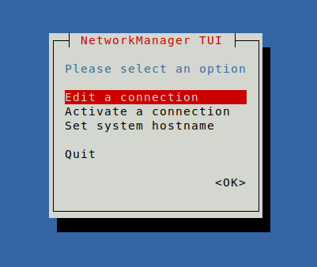

Click on '**Edit a connection**', press ‘**Enter**’. Use the ‘**Tab**’ key to navigate.

On the next screen, select the network interface from the list of interfaces & press ENTER key,

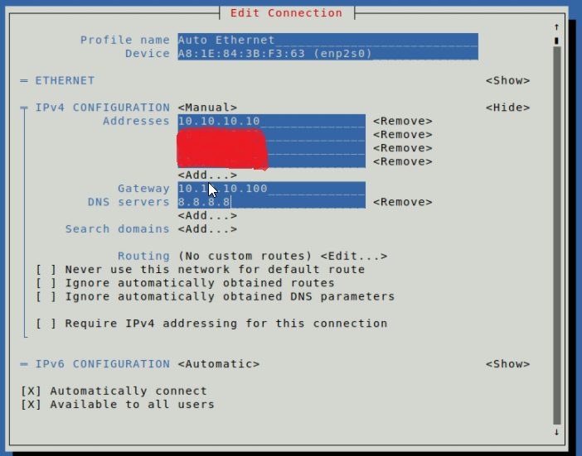

Add the IP address and other necessary details as required & complete the setup. Next, we need to restart the NetworkManager service to implement the changes,

**# systemctl restart NetworkManager**

## **2- Assigning IP using Network files**

Network files for all the network interfaces are located in the directory ‘/etc/sysconfig/network-scripts'. Open the primary network interface file i.e. enp0s3, & add the following content to the file. Add what’s not in the file.

**$ vi /etc/sysconfig/network-scriptsifcfg-enp0s3**

**DEVICE="enp0s3"**

**BOOTPROTO=static**

**ONBOOT=yes**

**TYPE="Ethernet"**

**IPADDR=10.10.10.10**

**NETMASK=255.0.0.0**

**GATEWAY=10.10.10.100**

**HWADDR=32:0A:21:54:ND:6D**

Save the file & restart the network service for changes to take effect.

**# systemctl restart network**

After the service has been started, our static IP has been assigned to our CentOS 7 system. To verify the assigned IP address, use the IP command,

**# ip -a**